Name – Rakshak Dhone

PRN- 22311129

Roll No - 282037

**Assignment -7**

**c++ implementation:**

Known facts: fever, cough.

Rules:

* If fever and cough → flu
* If flu and sore_throat → infection
* If fever → infection

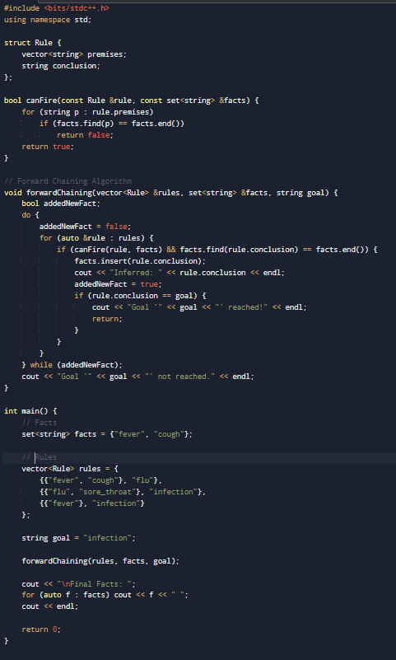C++ implementation:

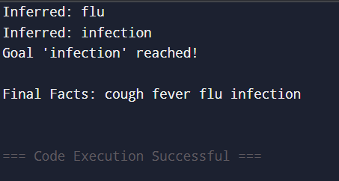Output: